**CI tool**

Jenkins is one of the Continuous Integration tool

It uses Maven to build the project continuously for every minute if there is a change in the code

**How it works**

Firstly Create a Maven Project and push it in Github

Configure Maven Project in Jenkins using Github Url

When you change the code in eclipse and push it in github , then Jenkins builds the code and runs the test code. If tests are passed then **build is success.**

**Jenkins observes the code in github for every minute, if there is achange then only it builds the code**

Download Maven from Apache Maven Site

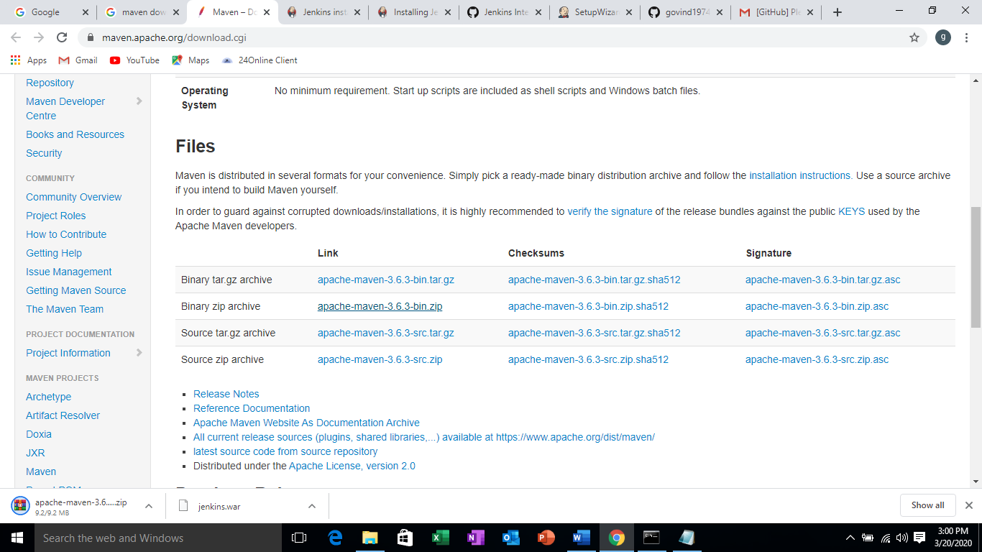

Unzip the file

Download Git

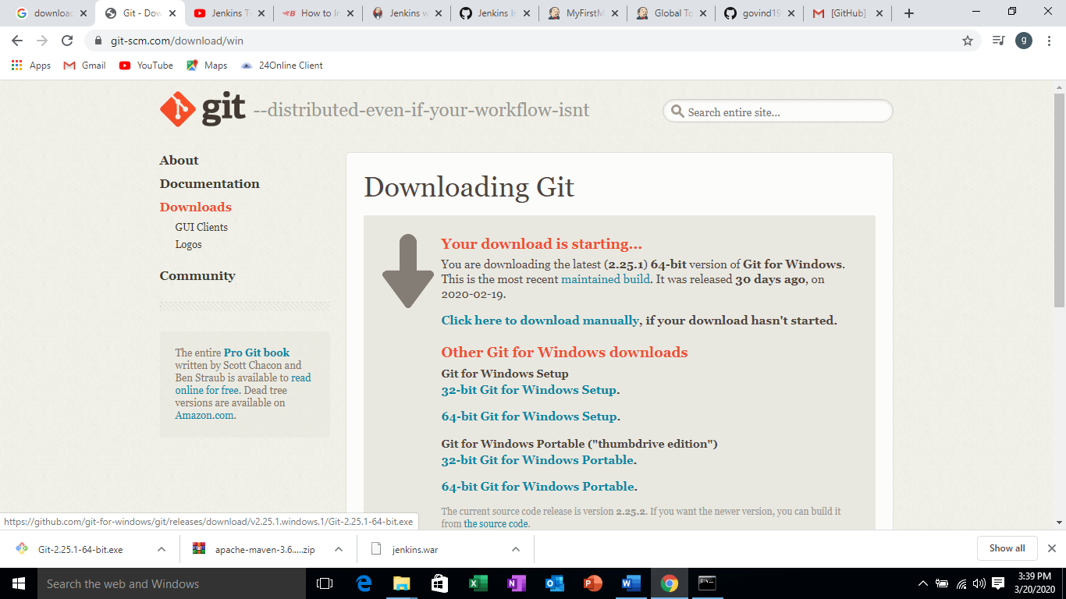

Run Git-2.25.1.exe to install Git

Download Jenkins

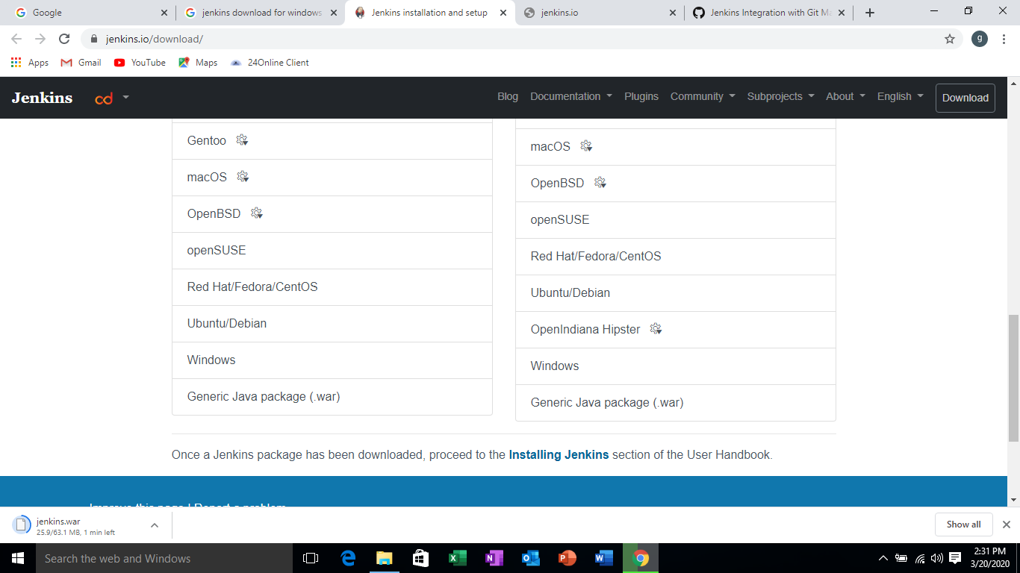

Run Jenkins in command prompt where Jenkins is resided

If Java command is not recognized, then set the path

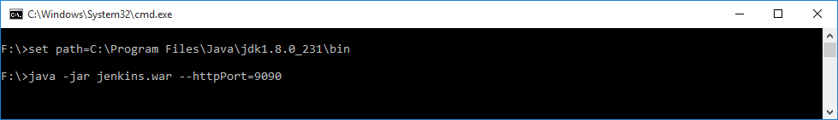

The following screen is displayed and Jenkins started

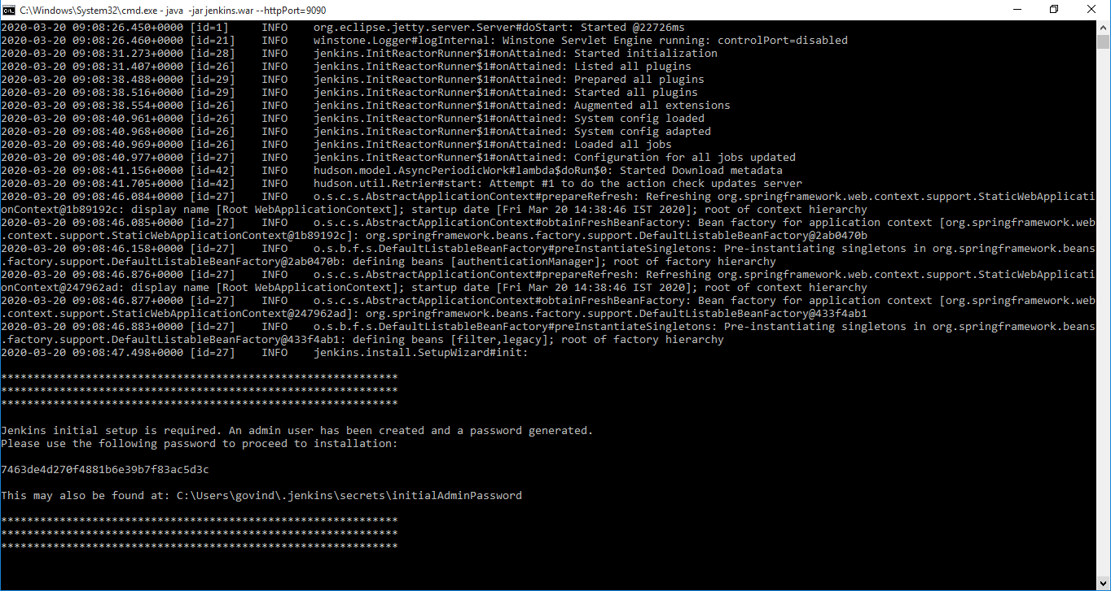

Go to C:\users\<your computer name>/.jenkins/secrets/ folder and open initialAdminPassword file in notepad.

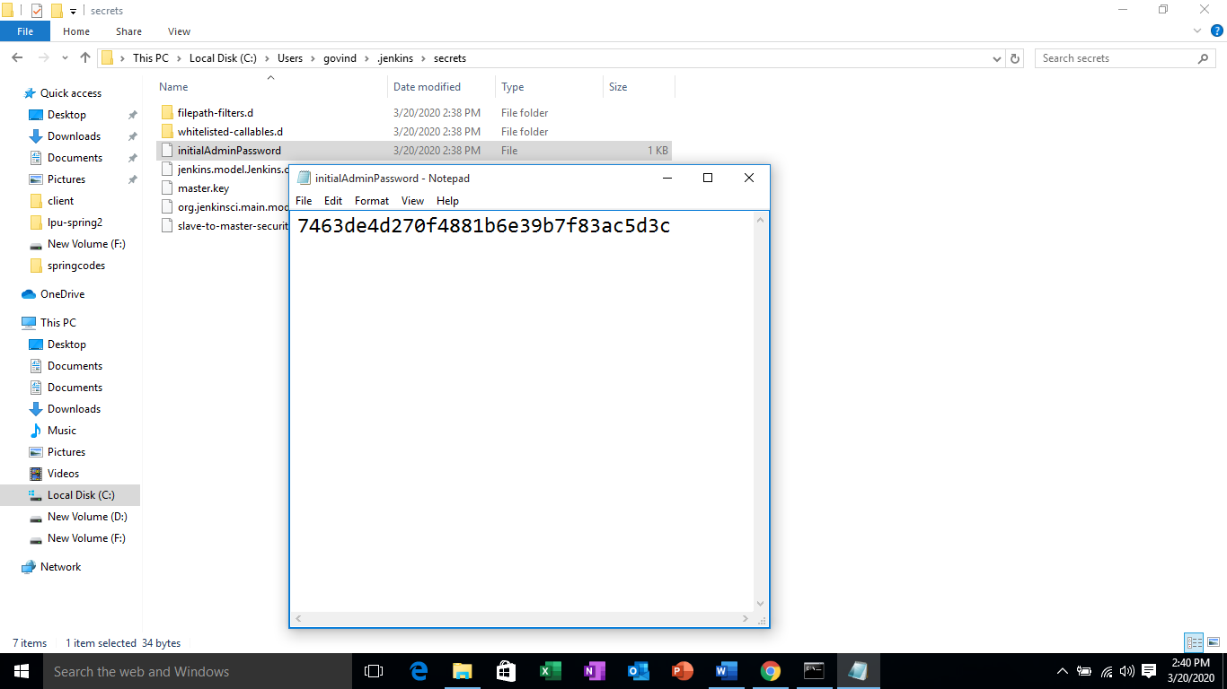

Start the Jenkins server

Type the url in the browser

<http://localhost:9090/>

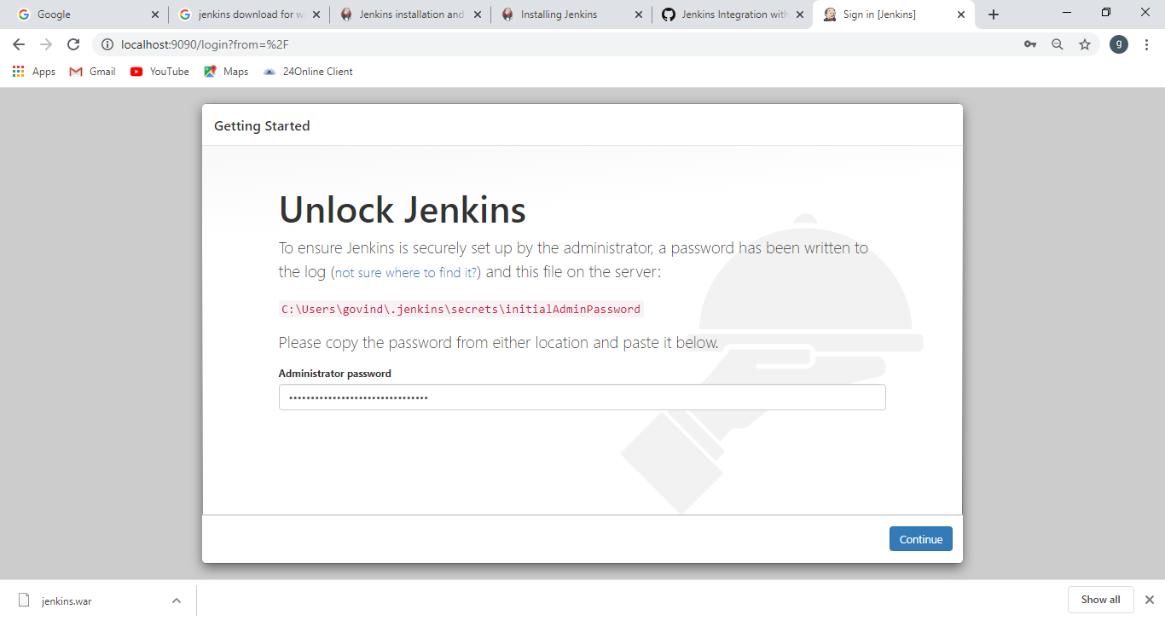

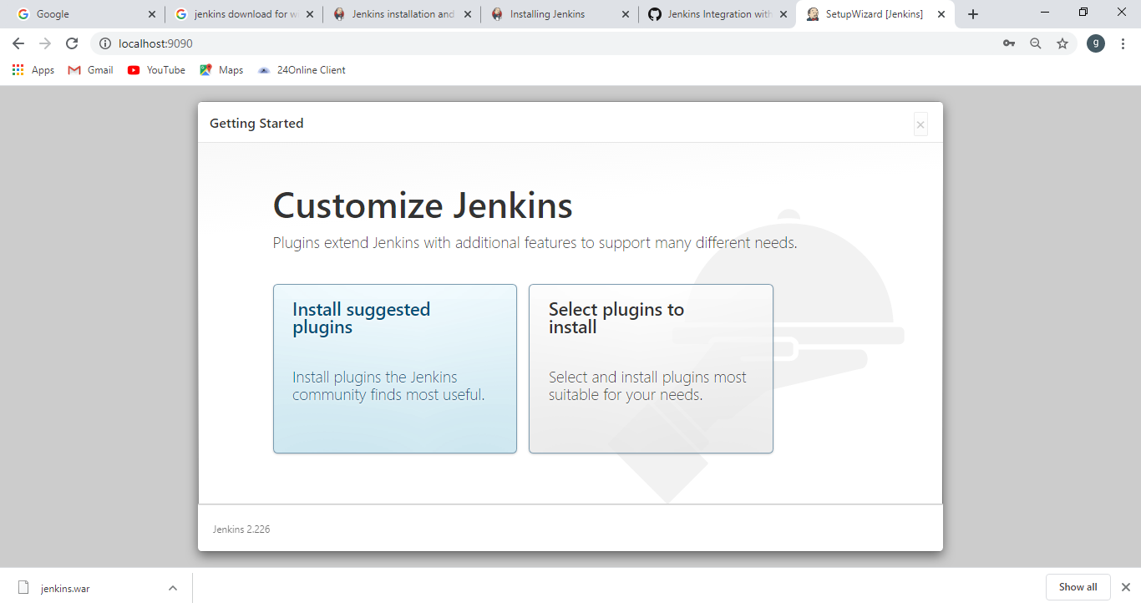

The below screen is automatically installs the basic plugins including GIT plugin

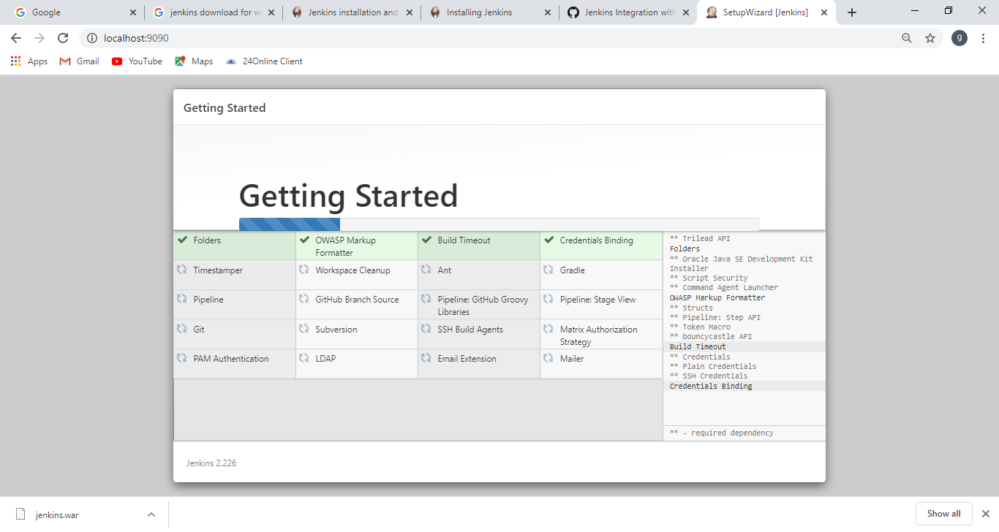

The screen is displayed to change the password

Enter the password, confirm password and click next to continue.

Continue to work in jenkins

After Logout and Again Login

Start the Jenkins by typing the url <http://localhost:9090>

Type username 🡪admin

Type password 🡪 enter changed passwordif changed otherwise enter initialAdminPassword

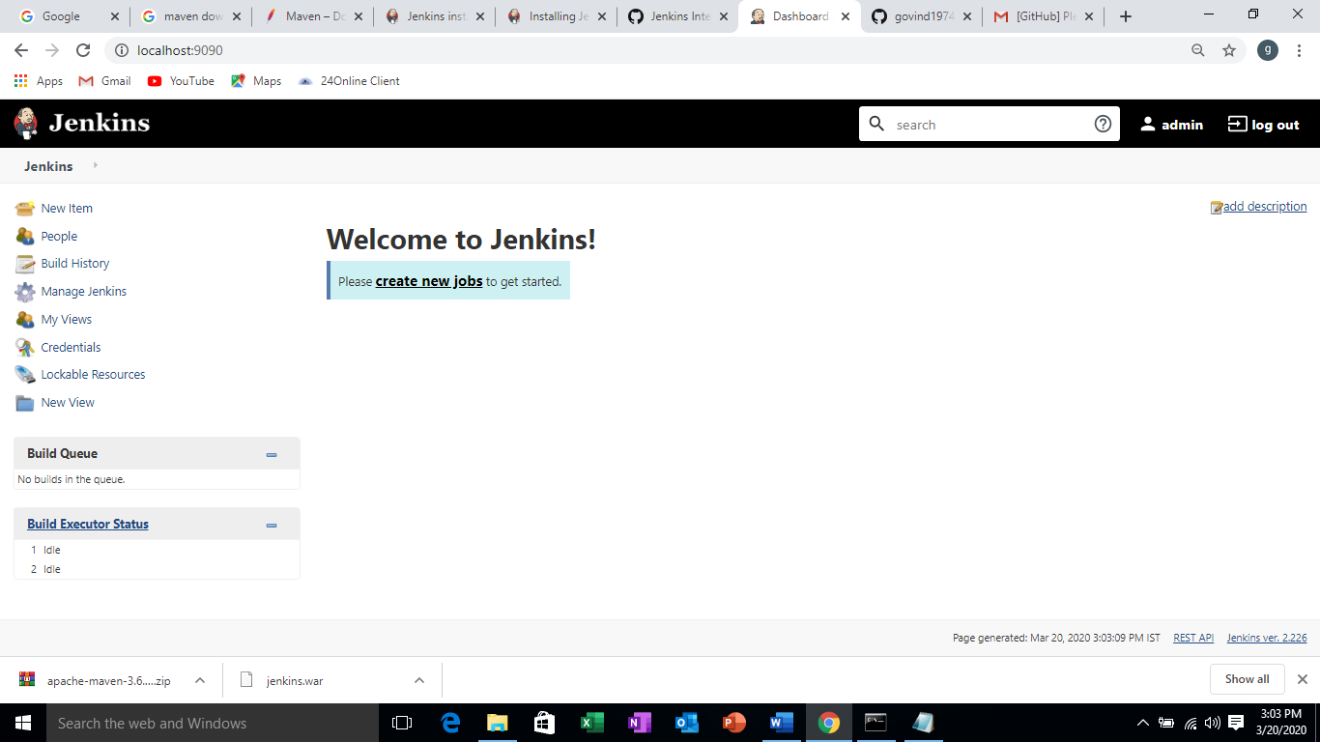

**Install Maven Plugin**

Go to Manage Jenkins 🡪 Manage Plugins 🡪 Available tab

Type Maven Integration in Filter text box

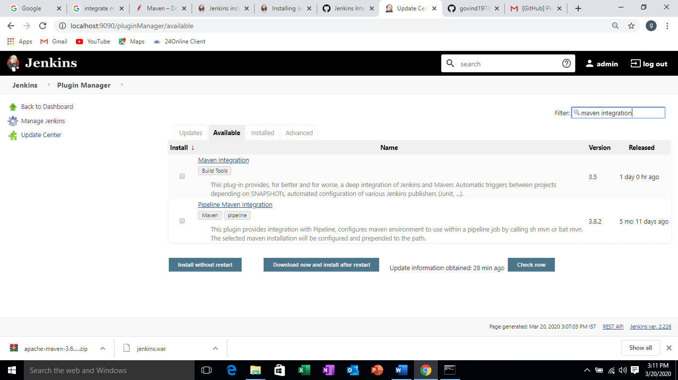

Check Maven integration and click on maven without restart

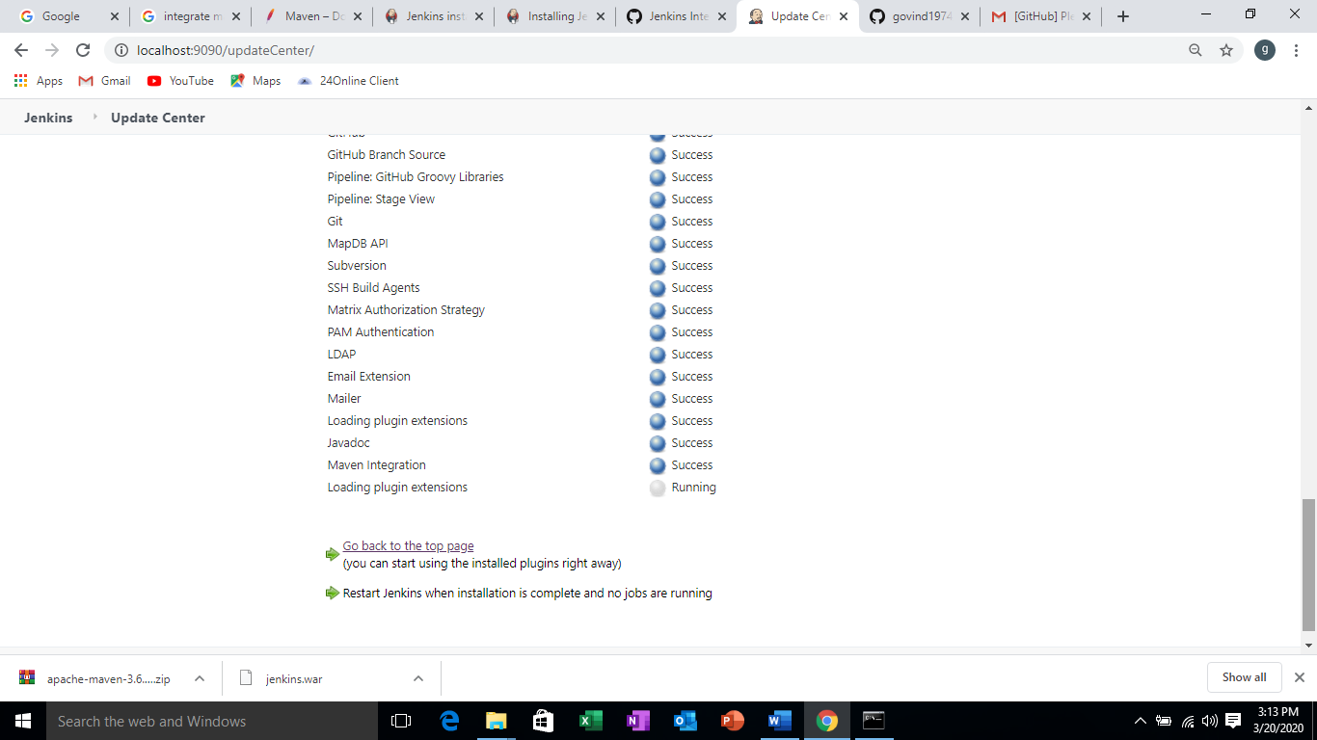

**Global tool Configuration**

**Goto Manage Jenkins 🡪 Global tool Configuration**

Set up JDK Path 🡪 where JDK Is installed

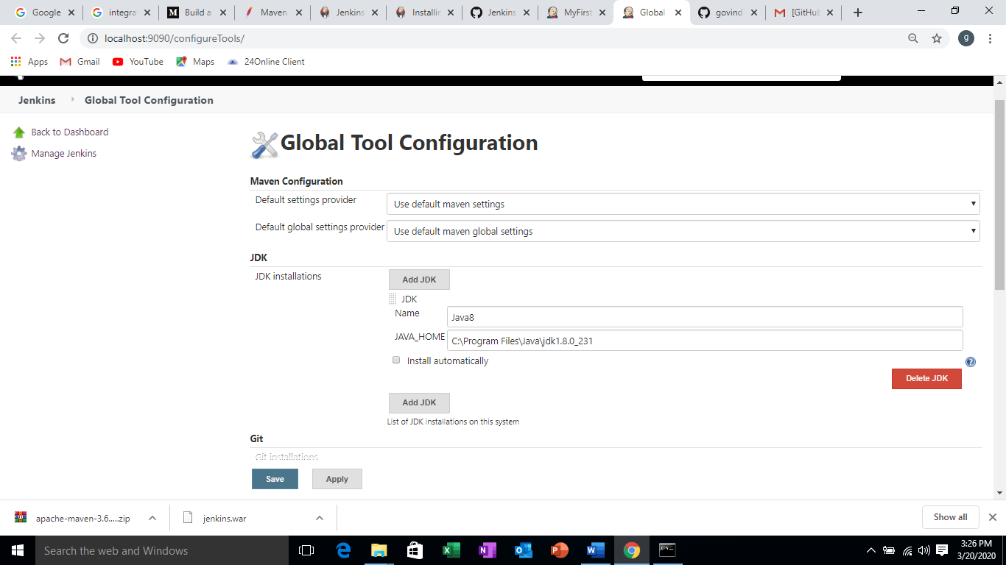

Set up Git path 🡪 installation path of Git

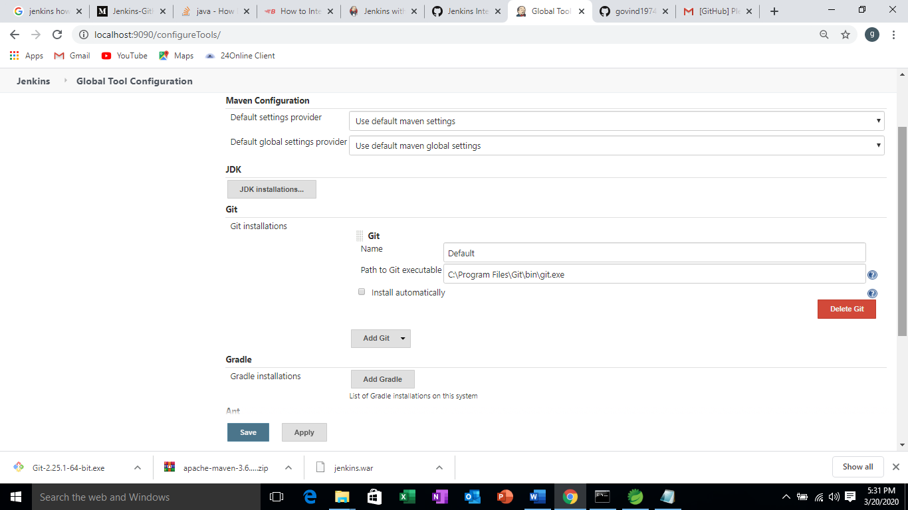

Set up maven path 🡪 where maven is resided(Maven is not installed. After downloading unzip the file)

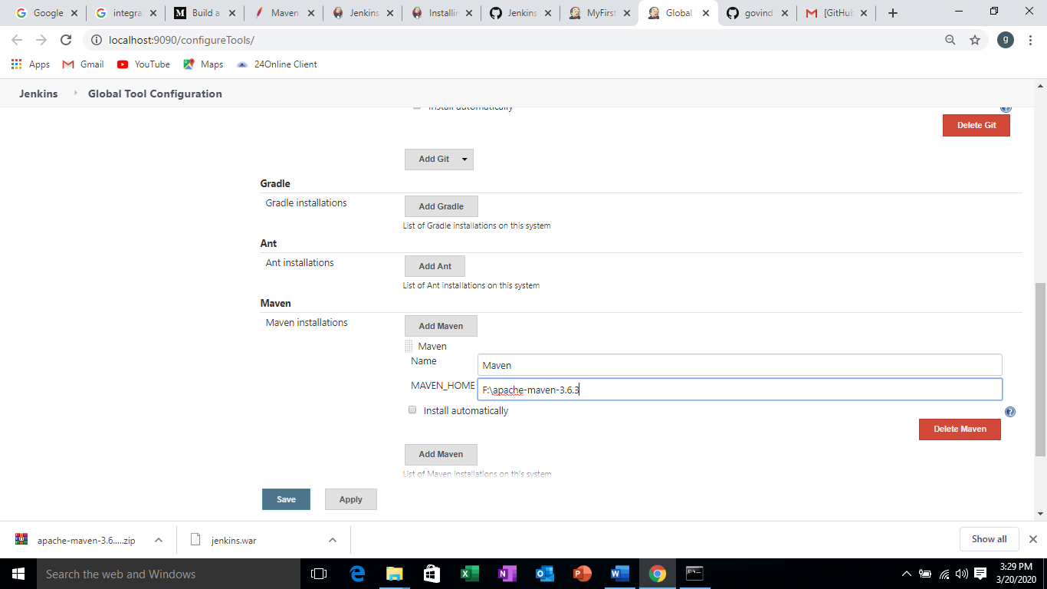

Creating a New Item

Go to Jenkins dashboard 🡪 new Item 🡪 Enter an item name and click on Maven project and click on OK

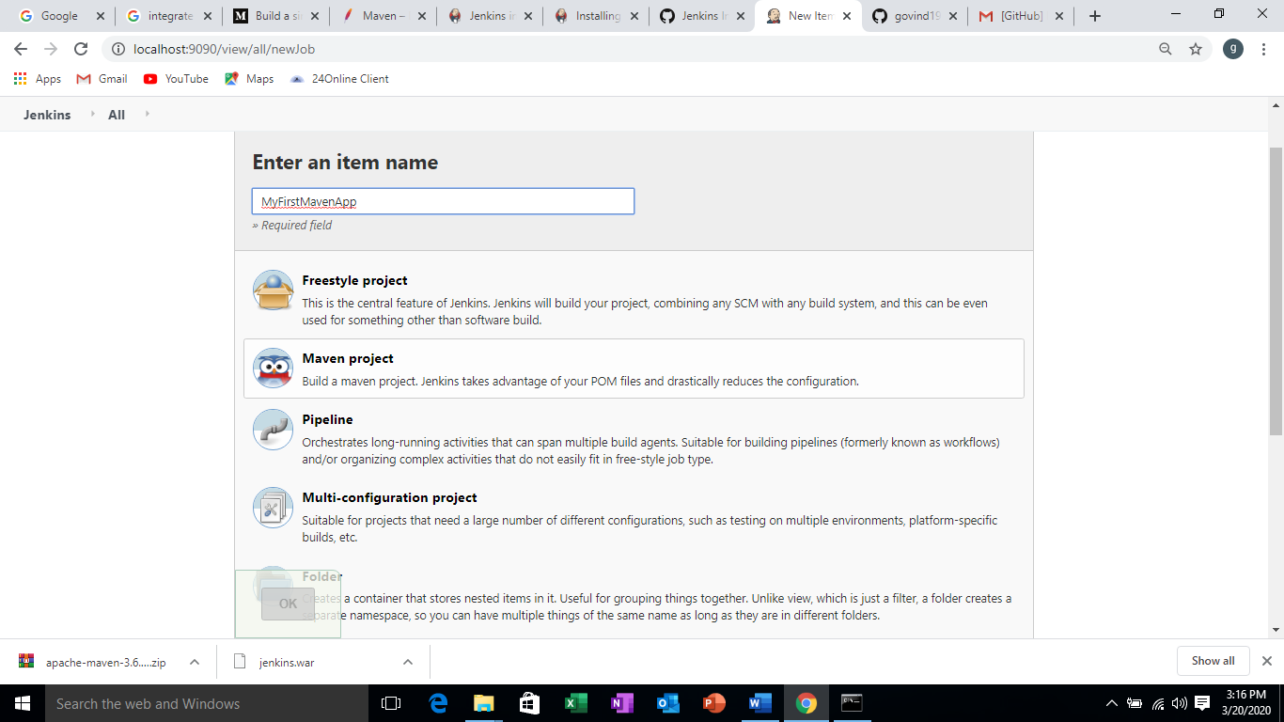

Copy the Git URL from Github by clicking on **Clone or Download** button

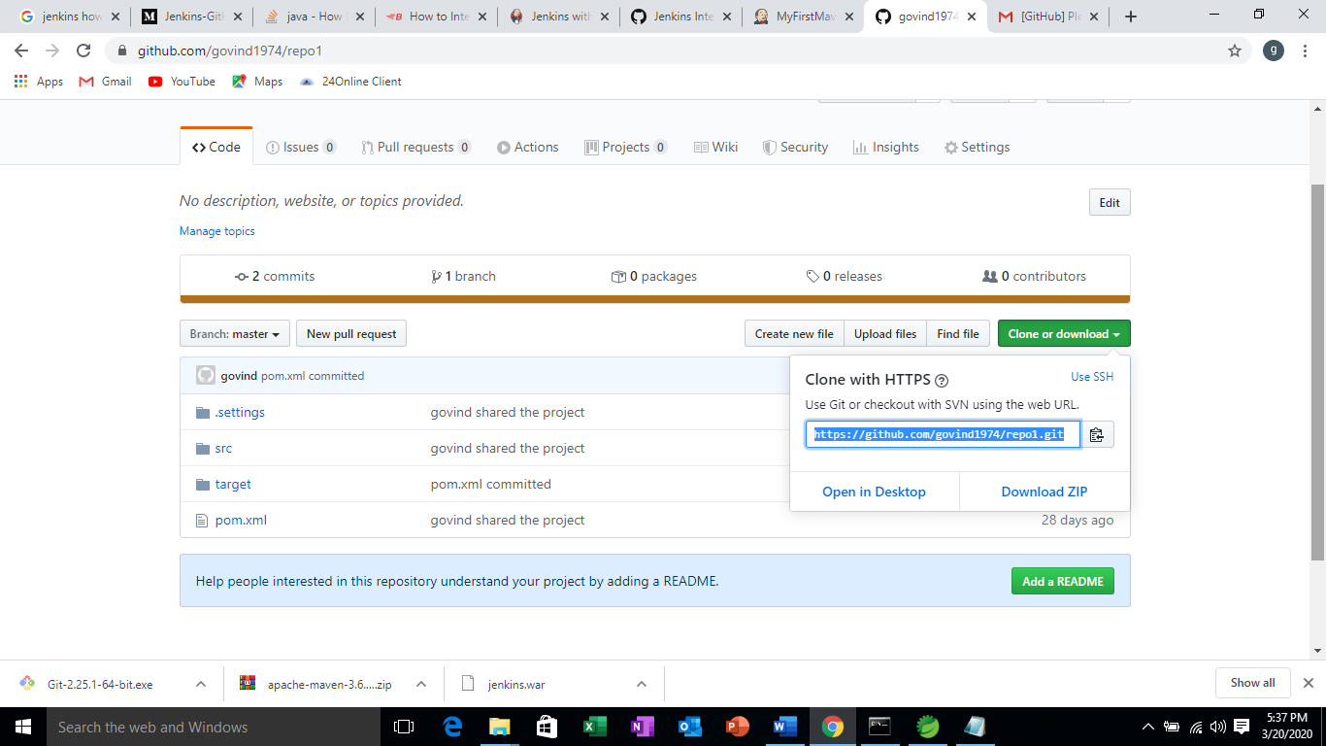

**Paste the Github url in the Repository URL text box**

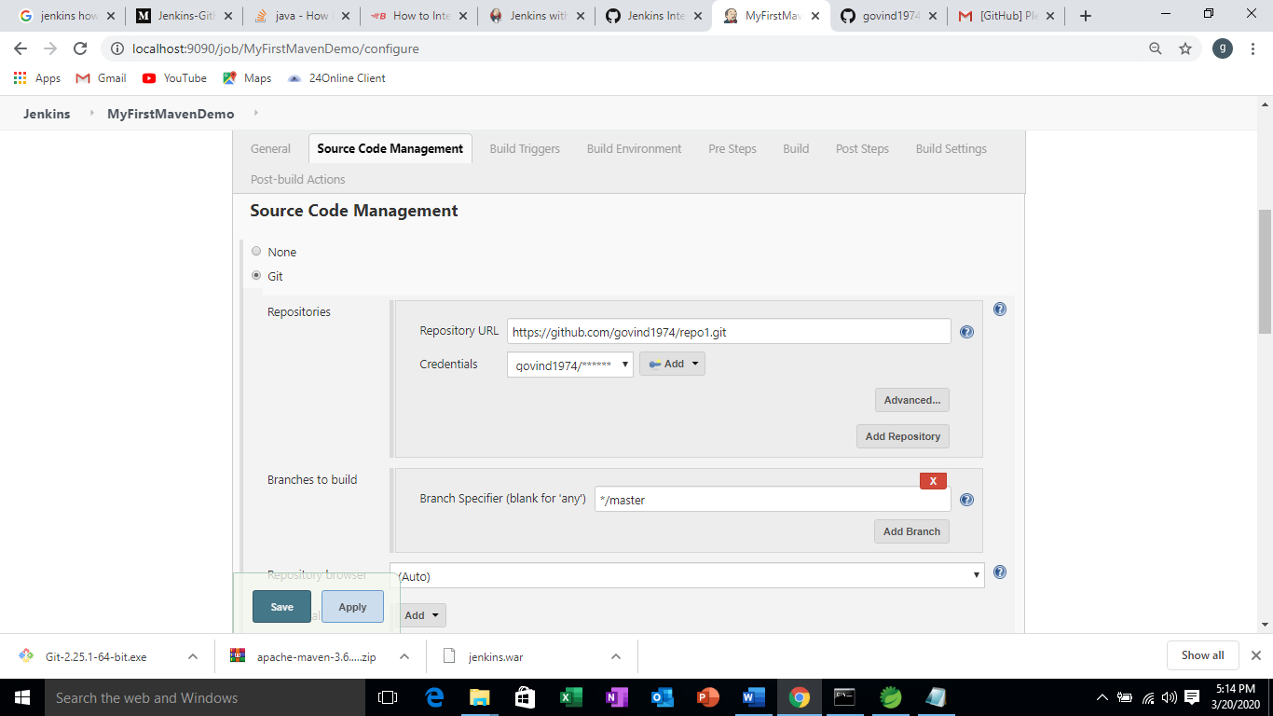

Configure Credentials by clicking on Add button

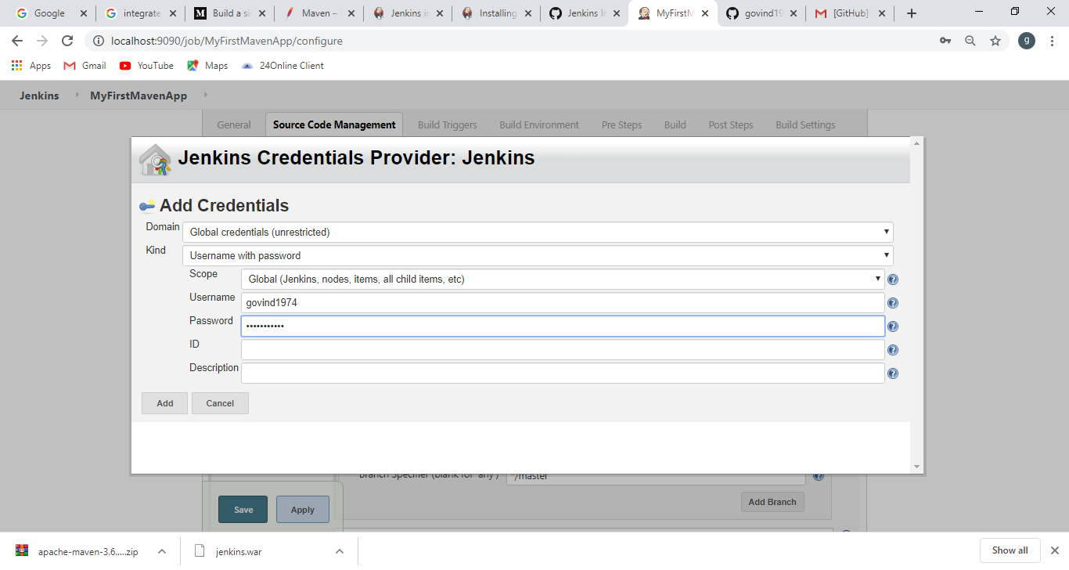

Go to Build triggers 🡪 select Poll SCM and enter the schedule * * * * *

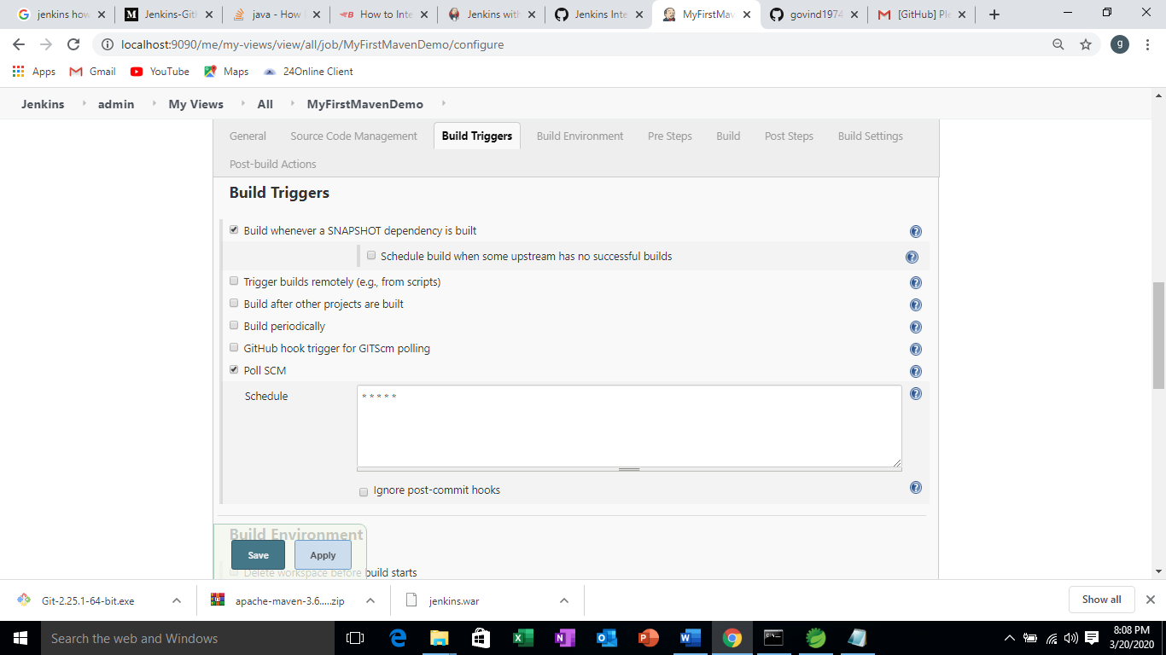

Change the code in the eclipse maven project and push it on the Git hub.

Automatically, code is built in Jenkins and view the test result

Here in this case the code is trying to build for every minute. If there is a change in the code then Jenkins bulid the code using maven

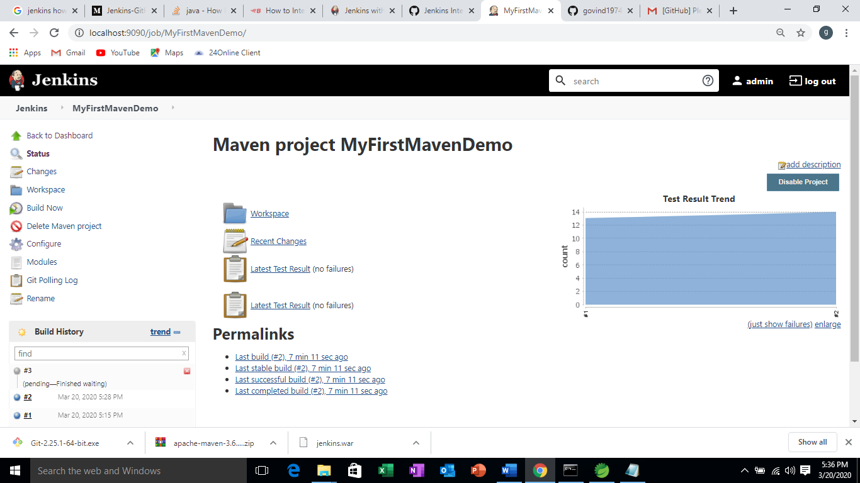

**Other schedules to be configured in POLL SCM**

POLL SCM

(* * * * * ) represents (minute, hour, day_of_month, week, day_of_week)

range (0–59, 0–23, 1–31, 1–12, 0–7)

sunday -0, monday-1, tuesday-2 ,…,saturday-6

January-1, Feb-2, …,Dec-12

Example :

/5 * * * * — every 15 min

0 * * * * — every hour

0 0 * * * — every 00:00 hours

00 14 10 3,6,9,12 * — at 2:00 PM on 10th of March, June, September and December

25,50 1 15 * 2 — at 1:25 AM, 1:50 AM every Tuesday and on 15th of every month.

00 21 * * Mon,Wed,Fri — at 9.00 PM every Monday, Wednesday, Friday

*/5 * * * 1–5 — every 5 minutes during the 5 working days (Monday — Friday), every week and month

* */4 * * Sun — every minute past every 4th hour on Sunday